SỞ GIÁO DỤC - ĐÀO TẠO TP.HCM  TRƯỜNG THPT TRƯỜNG CHINH  KEY  E 10  Đề chính thức |  | ĐỀ KIỂM TRA HỌC KỲ I  Môn: TIẾNG ANH 10 - Năm học: 2016 - 2017  Thời gian làm bài: 60 phút  (Đề thi có 03 trang)
 | Mã đề thi 137
Họ và tên thí sinh: …………………………………………………
Số báo danh: ……………………………………………………….
1 blank / sentence = 0.2 m
SECTION A: MULTIPLE CHOICE (6 points):
Mark the letter A, B, C, or D on your answer sheet to indicate the word whose underlined part differs from the other three in pronunciation in each of the following questions:
Question 1: A. foot B. moon C. afternoon D. cartoon
Question 2: A. rain B. channel C. paper D. famous
Question 3: A. accuracy B. multiply C. daily D. beauty

Mark the letter A, B, C, or D on your answer sheet to indicate the word that differs from the other three in the position of primary stress in each of the following questions:
Question 4: A. comedy B. family C. usually D. afternoon
Question 5: A. miraculous B. technology C. computer D. newspaper

Mark the letter A, B, C, or D on your answer sheet to indicate the correct answer to each of the following questions:
Question 6: One of the main purposes of the text is to encourage students______________in groups.
A. to be studying B. studying C. to study D. study
Question 7: Many peasants find it difficult to make ends meet.
A. apply new farming methods B. get plenty of food
C. earn enough money for living D. better their life
Question 8: Internet cafes allow you ______________ your web-based e-mail account.
A. to access B. accessing C. access D. be accessed
Question 9: The cheese is soft and white and absolutely______________.
A. glorious B. delicious C. interesting D. tasteful
Question 10: ___________his mental illness, the boy can’t keep pace with his classmates.
A. Despite B. Although C. Because of D. Because
Question 11: They introduced new farming methods, which _______ in bumper crops.
A. resulted B. finished C. offered D. completed
Question 12: Thomas said that he would be home______________.
A. the next day B. then C. tomorrow D. next week
Question 13: She knows a lot of people _______live in Hanoi.
A. who B. whose C. where D. which
Question 14: The students became more anxious as their exams drew nearer.
A. worried B. delighted C. bored D. excited
Question 15: ______ eat a lot of ice – cream when you were a child ?
A. Were you used to B. Were you using to C. Did you used to D. Did you use to
Mark the letter A, B, C, or D on your answer sheet to show the underlined, part that needs correction:
Question 16: Approximately, 70% of all parents let their children to attend school
A B C D
Question 17: A cell phone used to talk to people who live far from you.
A B C D
Question 18: I saw a stranger which was walking in the street in front of my house.
A B C D
Question 19: The table was sending from California to New York by plane.
A B C D
Question 20: Despite of her age, she works very hard.
A B C D
Read the following passage and mark the letter A, B, C, or D on your answer sheet to indicate the correct word or phrase that best fits each of the numbered blanks from 21 to 25:
Society has changed in many ways (21) ______________ the introduction of computers, and people’s lives at home and at the office have been affected. Most people are working for fewer hours per week than they (22) ______________ to, and manufacturers and advertising agencies are becoming much more interested in how people spend this extra leisure time. One recent report stated that, (23) ______________ the number of hobbies had not increased, each hobby had become more specialised.
A second finding is that nowadays, many managers would rather (24) ___________ time with there families than stay late in the office every day. Home life is seen to be just as important as working. Some companies now make managers take their annual (25) _________ even if they don’t want to, because this leads to such an improvement in their performance if they have some rest.
Question 21: A. for B. at C. from D. since
Question 22: A. ought B. want C. used D. have
Question 23: A. as B. but C. because of D. although
Question 24: A. to spend B. spend C. spending D. spent
Question 25: A. holidays B. festivals C. benefits D. events
Read the following passage and mark the letter A, B, C, or D on your answer sheet to indicate the correct answer to each of the questions from 26 to 30:
Most Americans look forward to their vacation. Most American employees receive an annual vacation with pay, and it is traditional to use this time off for travel.
Traveling within the United State is very popular because foreign travel generally takes more time and money. However, those who want to travel outside the USA are free to go almost everywhere. Obtaining a passport is a routine matter. Every year about thirteen million people travel abroad. The most popular periods are during the summer and the two-week school break on Christmas and New Year holidays.
These periods are also the most crowded and the most expensive time to travel, so people who can adjust their schedules sometimes choose to travel in the autumn.
American tourists often travel by car. Most families own a car, and those who do not have can rent one. Cars are usually the most economical way to travel, especially for families. It is also fairly fast and convenient. Excellent highways with motels and restaurants nearby connect the nation’s major cities. They enable tourists to travel at a speed of 55 to 66 miles an hour. Tourists that want to travel faster often fly to their destination and then rent a car when they get there.
Question 26: According to the writer, ________.
A. Americans do not like traveling B. it is impossible to have a day- off in the USA
C. Americans have no vacations D. most Americans are fond of traveling
Question 27: In the USA, to obtain a passport is _______.
A. difficult B. time – consuming C. easy D. impossible
Question 28: There are many people traveling _______.
A. on Women’s Day B. on Christmas and New Year
C. in the winter D. on Thanksgiving
Question 29: _______ are the most popular means of transport in the USA.
A. Ships B. Planes C. Cars D. Buses
Question 30: In the USA, _________.
A. the highways are not in good condition
B. tourists cannot rent a car
C. along the highways there are motels and restaurants available for tourists
D. there are not any highways

SECTION B: WRITING (3 points):
Use the correct forms of the words in brackets:
- We ( just / finish)______________ dinner when they came. (HAD) JUST FINISHED
- The children(watch) ______________ TV at this moment. WERE WATCHING
- My brother has stopped (smoke) ______________ because of his health. SMOKING
- If the roads (widen) _________, cars and lorries can get to our village. ARE WIDENED
- I (study) ________ my English lesson at 7 p.m last Sunday. WAS STUDYING
Use the correct tense / forms of the verbs in brackets:
- We expect students not to talk during the exam (Passive voice)
STUDENTS ARE EXPECTED NOT TO TALK DURING THE EXAM.
- Lan said, “ I don’t understand these two lessons at all”.
LAN SAID (THAT)/TOLD ME (THAT) SHE DIDN’T UNDERSTAND THOSE TWO LESSONS AT ALL.
(Hs không đổi “these”: không trừ điểm)
- Is this the book? I gave it to you three days ago. (Relative Clause)
IS THIS THE BOOK WHICH/ THAT I GAVE TO YOU THREE DAYS AGO?
(Hs thiếu “?”: không trừ điểm)
- The boy is bored. His bike has been stolen. (Relative clause)
THE BOY WHOSE BIKE HAS BEEN STOLEN IS BORED.
- My brother gave up playing video games 2 months ago. (used)
MY BROTHER USED TO PLAY VIDEO GAMES 2 MONTHS AGO.
Finish each of the following sentences in such a way that it means the same as the sentence printed before it:
- He will do this with your kind (permit)______________. PERMISSION
- She sings (beautiful)______________. She is famous for her voice. BEAUTIFULLY
- Computer is a calculating machine which speeds up (calculate) CALCULATIONS.
(Hs thiếu “S”: không điểm)
- FORTUNATELY, I am having a day off tomorrow, so I can help you.
- Some computers games have been banned because they are too (violence) VIOLENT
SECTION C: LISTENING (1 point):
You will hear a telephone conversation. A girl wants to talk to Martin but he isn’t there. Listen and choose the correct answer. You will hear the conversation three times.
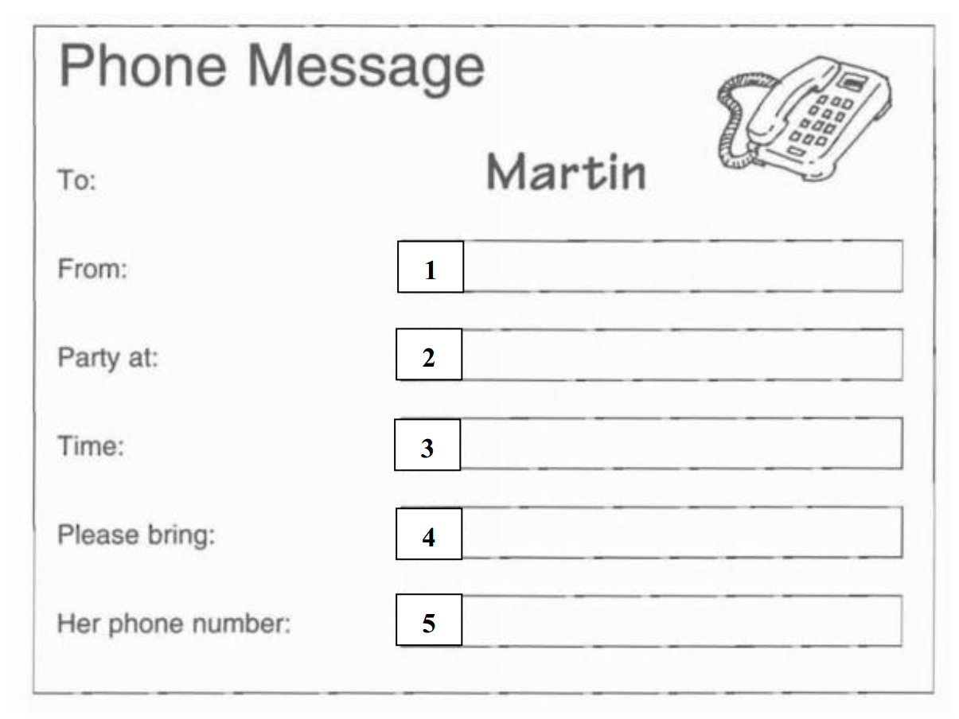
- A. ELAINE
- C. Grand Hotel
- B. 8h30
- A. a friend
- B. 7245936

______________  THE END  _______________

